CRM Project

Functional Specification - Enhancement

PP6_Contract Management Cancel End Contract

CM_090-160-200-E
CM_ENH_120

Deliverable Name | CM_ENH_120
Date | 11/18/2010
Revision | V1.0
Signed off By | Functional lead/PP6 Owner
Signoff Date

TABLE OF CONTENTS

1. Version 3
2. Approvals 3
3. Priority Mention the Priority of the object from the FRICEW list in ILM. Processing Mode (check all that apply) 4
Low Medium High 4
4. Enhancement Requirements Description 4
5. Impacted Systems 4
6. Approach to be followed 4
7. Roles and Volumes 5
8. Security & Control Requirements 5
8.1 Security Requirements 5
8.2 Control/Audit Requirements 5
9. Dependencies 6
9.1 Development Dependencies 6
9.2 Run/Execution Dependencies 6
9.3 Archiving Dependencies 6
10. Execution Steps 6
10.1 Process Description 6
10.2 Process Flow 6
10.3 As-Is Systems Referred To 7
10.4 Processing Options 7
11. Enhancement Description 8
11.1 Detailed Description of the Enhancement 8
11.2 UI Design and Screen Flow < Mention the WEBUI Design in the sense the mock up screens and the navigation flow between the screens etc> 11
11.3 Access Method or Path for Enhancement 11
11.4 Required Custom Tables (if known) 11
11.5 Error Handling Rules 11
12. Enhancement Reconciliation & Testing Requirements 11
12.1 Data Validation 12
12.2 Testing Reconciliation 12
12.3 Performance Issues 12
13. Additional Information 12
14. Open Items 12
15. Functional Unit Test cases < 12
Cancel End Contract – Disconnect Order is present 12

Version
Ensure that any approved change requests that affect scope are documented in the revision history and include CR #.
Version | Change Description | Author | Date Released | Sections Impacted
Enter in the version number | Brief description of the change | Who made the change | Date change was made | Mention the sections impacted with this change
1.0 | Document Creation | Ronda Clandening | 11/18/2010
1.1 | Update Interaction Record verbiage – Item 5, page 10  Update landing page Item 4, page 10 | Judy Jarone | 02/16/2011 | 11.1
1.3 | Updated complete names of dependent PP6’s in section 9.1. On page 10 step 3 was re-worded. | Ronda Clandening | 3/1/2011 | 9.1
1.4 | Change Request CHG03955 Restrict the Cancel Notification candidates to Notification Types of D2 and D3  Change Request CHG03962  Notification Cancellation Error handling | JJarone | 5/18/2011 | Section 11.1, Item #3 page 10.

Approvals
The individuals listed below will be required to review and approve this document.
Reviewers Title | Reviewer Role | Name
Project Title of Reviewer | Reviewer's Role (Responsible, Approve, Consult, Inform) | Reviewer's Name
Technical Team Lead | Approve | V. Krishna Karunakaram
CRM Functional Team Lead | Approve | Robert Smeltekop
Business Owner | Approve | Anita Jackson
Business Owner | Approve | Diane Couture
Business Owner | Approve | Corey Williams

Priority
Mention the Priority of the object from the FRICEW list in ILM.
Processing Mode (check all that apply)

Low Medium High
N/A

Enhancement Requirements Description

The Cancel Contract (Reversal) will be used when a request is made to reverse a New Contract (Move In) or End Contract (Move Out). The system will determine which processing option is allowed based upon the population of the Contract’s Start Date or End Date. If the contract’s end date is not populated then the cancel of the New Contract will be allowed, if the contract’s end date is populated the Cancel End Contract will be allowed.

The user will select Cancel Contract from the Contract Management Work Center sub menu Cancel Contract to start the process.

This document will pertain to the Cancel End Contract (Reverse Move Out).

Impacted Systems

CRM 7.0 Web IC : CRM 7.0 Web Client Interaction Center Production System
ECC 6.0 / IS-U ECC 6.0 / IS-U : Back End Production System (Enterprise Central Component)

Approach to be followed
An enhancement will be required to validate the cancel (reverse) New Contract and cancel (reverse) of the Forced End Contract.

Roles and Volumes

In terms of volume, this is a medium frequency process that could be performed many times in a day by several of the business roles.

Role | Estimated Volume Requirement | Comments
List name of role; should come from the list of security roles | Enter the estimated volume requirements that will be needed by the Go-Live date | Enter other comments including if this development will require additional communication and/or training
CSR 2 | 1000 times per day
CSR 3 | 1000 times per day
CSR 4 | 25+ times per day
VCC MGMT | 25+ times per day
BCOS | 15-20 times per day
Billing | **times per day
Consumer Affairs | **times per day
Revenue Recovery | **times per day
Gas Trans | **times per day

Security & Control Requirements

Security Requirements
This enhancement will be available to the following business roles:

CSR 2
CSR 3
CSR 4
VCC MGMT
BCOS
Billing
Consumer Affairs
Revenue Recovery
Gas Trans

Control/Audit Requirements
<Describe any control requirements that need to be put in place as a result of this development object>.
- If applicable, please answer the question and also provide detail to the question.
- The questions listed below are not all inclusive to the control requirement that may be required. If there are any other controls requirements please document them as well.

- Indicate if this enhancement is being developed to address a control requirement?
- Financial/SOX Impact - Does the enhancement have any impact to financial reporting? If yes, is the amount significant (i.e. greater than $35 million annually)? Please provide an estimate.
- Regulatory Impact - Does the enhancement have any impact to regulatory compliance (i.e. FERC, NERC, etc)? If yes, please provide a reference to the rule and describe the impact.
- Operational Impact - Is the enhancement relied upon for a mission critical process or providing services to customers? If yes, please identify the mission critical process and describe how this enhancement is used in the context of this process.

Dependencies

Development Dependencies
This is dependent on New Contract creation being complete: CM-090-090

This is dependent on CM-090-090-075-E.CM.ENH.350 (Notification View), which is dependent on CM-060-230-020-E.SO.ENH.050 (Service Orders).

Run/Execution Dependencies
Business Partner and Premise must be confirmed.

Archiving Dependencies
- Not Applicable

Execution Steps

Process Description
This process may be accessed in 2 ways:
- A user may click directly on Contract Management Work Center
- A user may select the dropdown from Contract Management Work Center, and then select the sub menu Cancel Contract (This will be the Best Practice method)

Process Flow

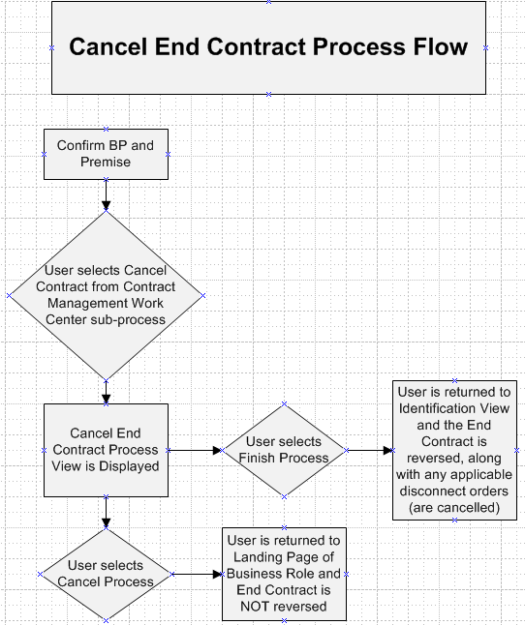

As-Is Systems Referred To
CRM 5.0 Win IC : Win Client Interaction Center - Production System
ECC 6.0 / IS-U ECC 6.0 / IS-U : Back End Production System (Enterprise Central Component)

Processing Options
Processing Mode (Select one of the following)
Batch Online – via Transaction Code Online – via Menu Path
On demand

Frequency (Select one of the following)
Daily
Weekly Quarterly
Monthly Annually
Other (If other, describe here)

Lifetime of Development (select one)
Permanent
Temporary, e.g. until rollouts are complete, specify details here

Enhancement Description
An enhancement will be required to validate the cancel (reverse) End Contract.

Detailed Description of the Enhancement

Selection of Cancel End Contract Process

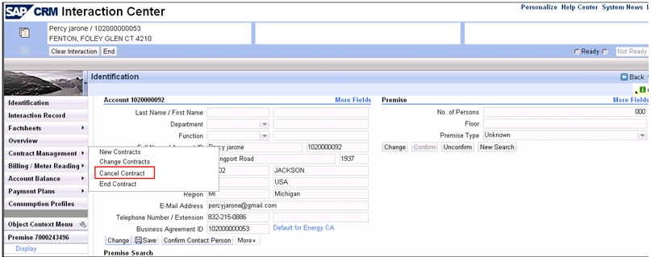

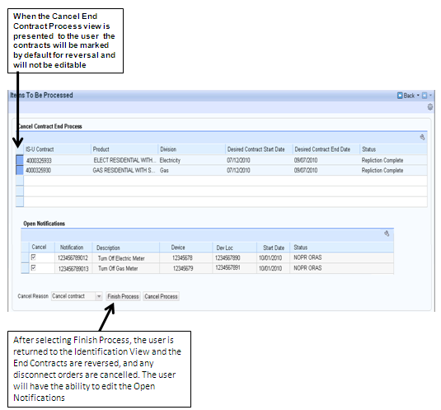

There will be times when a user may have to Cancel (reverse) an End Contract. These are the steps that will be performed by the user for Cancelling the End Contract in CRM 7.0:

- User selects Cancel Contract from the Contract Management sub menu
- Cancel End Contract Process View is displayed
- User selects ‘Finish Process’ (if error, user will receive message and select ‘Cancel Process’, and be given standard “Are you sure you want to cancel” pop up)
- The Identification view is displayed if the user selects ‘Finish Process’ or ‘Cancel Process’
- END

These are the steps the system will have to perform when the user selects ‘Finish Process’ in order for the user’s process to be successful:
- The user will select the Cancel Contract from the Contract Management sub menu and launch the “Cancel End Contract” process. Validations will be invoked as standard functionality (eg the contract has already final billed). If the method identifies an error was returned (eg there is a future dated New Contract), then the user will receive a system message (see details of messages in section 11.5 message 1.2). For any other system errors (final billed accounts, or unknown system errors), message 1.1 will display. The user will then be required to manually investigate and resolve the error in order to successfully reverse the End Contract.
- The Contract Reversal indicator will be marked by default, and the user will be unable to de-select the ‘Reversal Indicator’.
- Once the user submits the changes in CRM the system will check to see if there are any associated disconnect orders (Object type ZMOVOUTDOC, Attribute ReverseDiscOrders with a value of ‘01’)that are marked for reversal (cancel). If disconnections orders are found and marked for reversal (cancel), the orders will be reversed. The developer can determine the best approach to determine open notification that should be cancelled, but only notification types of D2 and D3 are applicable for cancellation. The user will be able to edit the orders marked for cancel if applicable.

In case cancellation of a notification fails a warning system message "Cancellation of Notification & Failed." should be displayed for each failure to let the user know. Also, the following should be written to the IR for each failed record:
App ID: CM_CNS_NOTI_FAILURE
Message: Cancellation of Notification & Failed.

- After the End Contract has completed successfully, any associated disconnections orders, if present are cancelled.
- Interaction Record notes are written for the Cancelled End Contract.

Please refer to PP6 CRM.PP6.CM-080-100-010-E.FO ENH 3820 Automatically Log System Notes on Interaction Record for details on Interaction Record Notes

- Interaction Record Note– Write to the Interaction Record.
  - APP ID: CM_CNEC
  - Message: “Contract with end date &1 reversed
&1 = Contract End Date

The Move Out Reversal workflow WS93000150 is triggered by the reversal of the move out document (ie is event driven) and processes the CAP loan notification and resets the dunning level where required. The Move Out Reversal workflow will be discussed in detail in the PP6.CM-090-160-220-W MO_Reversal Workflow.

UI Design and Screen Flow
< Mention the WEBUI Design in the sense the mock up screens and the navigation flow between the screens etc>

Access Method or Path for Enhancement
Execution: Custom Transaction Code:
Menu Path:
Standard Transaction Code:
Other: CRM 7.0 Web IC Navigation

Required Custom Tables (if known)
Table Name: NA
Table Description: NA
M/O | Field Description | Type (text or numeric) | Maximum Field Length | Value Restrictions? | Validations?
Mention M if the field is mandatory and O if the field is optional | Enter the field description | Enter the type | Enter the max. field length | Enter any value restrictions | Mention if any validations are required or else mention NA

Error Handling Rules
<Explain what the error handling rules would be if there are any for this development. For example, if an enhancement is scheduled to be printed and it does not, what should a user do to get this corrected?>

CRM 7.0 System Messages (Error if system unable to Reverse End Contract)
  - - “ All billing and/or payment documents must first be reversed”
  - - “End Contract date is before future dated New Contract date”

Enhancement Reconciliation & Testing Requirements

Data Validation
- Data validation will require the expected test cases execution and verifying the results based on business requirements. CRM project team along with their business support teams will be responsible to ensure this enhancement works.

Testing Reconciliation
- This enhancement will be tested by the teams (their security roles) who perform the New Contract process. Teams will include CRM project team, BTS support team, Call Center, BCOS, Revenue Recovery, Consumer Affairs, and Billing.

Performance Issues
NA

Additional Information
NA

Open Items
NA

Item # | Detailed Description | Proposed Solution
Insert number | Describe the item | Describe the proposed resolution

Functional Unit Test cases <
Test Condition Description | Input Data | Expected Results | Actual Results/Comments
Cancel End Contract – No disconnect order is present |  | End Contract is cancelled
Cancel End Contract – Future dated New Contract is present |  | User will receive message “End Contract date is before future dated New Contract date”
Cancel End Contract – Disconnect Order is present |  | End Contract is cancelled and disconnect order is cancelled

